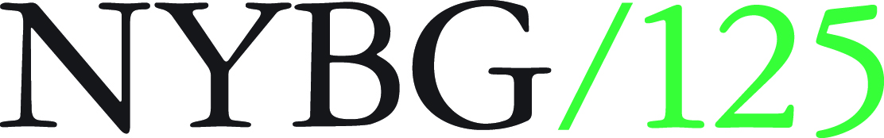

**Recommendation Form for the 2017 Summer Training Program in**

**Plant Diversity**

**(To be completed by Recommender)**

**Name of Applicant**: Click here to enter text.

**Name of Recommender:** Click here to enter text.

**Title:Click here to enter text.**

**How long, and in what capacity, have you known the applicant? How have you interacted with this person?**

|  |
| --- |
|  |

**Please carefully assess the applicant in the following areas. In making your assessment, please compare the applicant to other individuals you have known who have similar levels of experience and education.**

|  |  |  |  |  |  |
| --- | --- | --- | --- | --- | --- |
|  | **Superior** | **Good** | **Fair** | **Poor** | **No Basis for Assessment** |
| **Intellectual Ability** |  |  |  |  |  |
| **Motivation** |  |  |  |  |  |
| **Teamwork** |  |  |  |  |  |
| **Initiative** |  |  |  |  |  |
| **Self-discipline** |  |  |  |  |  |
| **Potential for Research** |  |  |  |  |  |
| **Communication Skills** |  |  |  |  |  |

**Please comment below on the applicant’s suitability for the Summer Training Program in Plant Diversity. Please take into consideration (1) the motivation and commitment of the student to explore or pursue a career in Biology or Plant Sciences, (2) the applicant’s ability to adapt to supervision and to work in a team setting, and (3) the applicant’s academic standing compared to other students in your department.**

**Overall Assessment**:





Signature: ______________________________________ Date: ________________________________

(Please return this form to Dr. Marcela Mora by e-mail at [marcela.mora@mobot.org](mailto:marcela.mora@mobot.org) no later than **Friday April 15, 2017**).